**Assignment 1: Homograph & Panorama**

# Part A – Calculation Homograph transform

1. We are given a two sets of 2D Cartesian matching points (${X^{'}}_{1}and {X^{'}}_{2}$) the idea is to find a matrix H of the format $H= \left[\begin{matrix}a & b & c \\ d & e & f \\ g & h & i\end{matrix}\right]$ so that $X_{2}=HX_{1}$  
   where $X_{1}=\left[{X^{'}}_{1}, 1\right] X_{2}=\left[x_{2}, { y}_{2}, w\right]-→X_{2}^{'}=\left[\frac{x_{2}}{w},\frac{y_{2}}{w}\right]=\left[x_{2}^{'}, y_{2}^{'}\right]$  
   from the equasion above we also get that: $$x_{2}=ax_{1}+by_{1}+c, y_{2}=dx_{1}+ey_{1}+f, w=gx_{1}+hy_{1}+i$$ 
   thus we can rewrite the equations like such $A= \left[\begin{matrix}x_{1} & y_{1} & 1 & 0 & 0 & 0 & -x_{1}x_{2}^{'} & -y_{1}x_{2}^{'} & -x_{2}^{'} \\ 0 & 0 & 0 & x_{1} & y_{1} & 1 & -x_{1}y_{2}^{'} & -y_{1}{y'}_{2} & -{y'}_{2}\end{matrix}\right]$ 
      
   for each matching points so that the following equation holds $$A\left[\begin{matrix}a \\ b \\ c \\ d \\ e \\ f \\ g \\ h \\ i\end{matrix}\right]=0$$
2. compute_homography_naive.m is attached.
3. 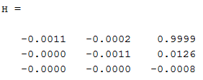
4. 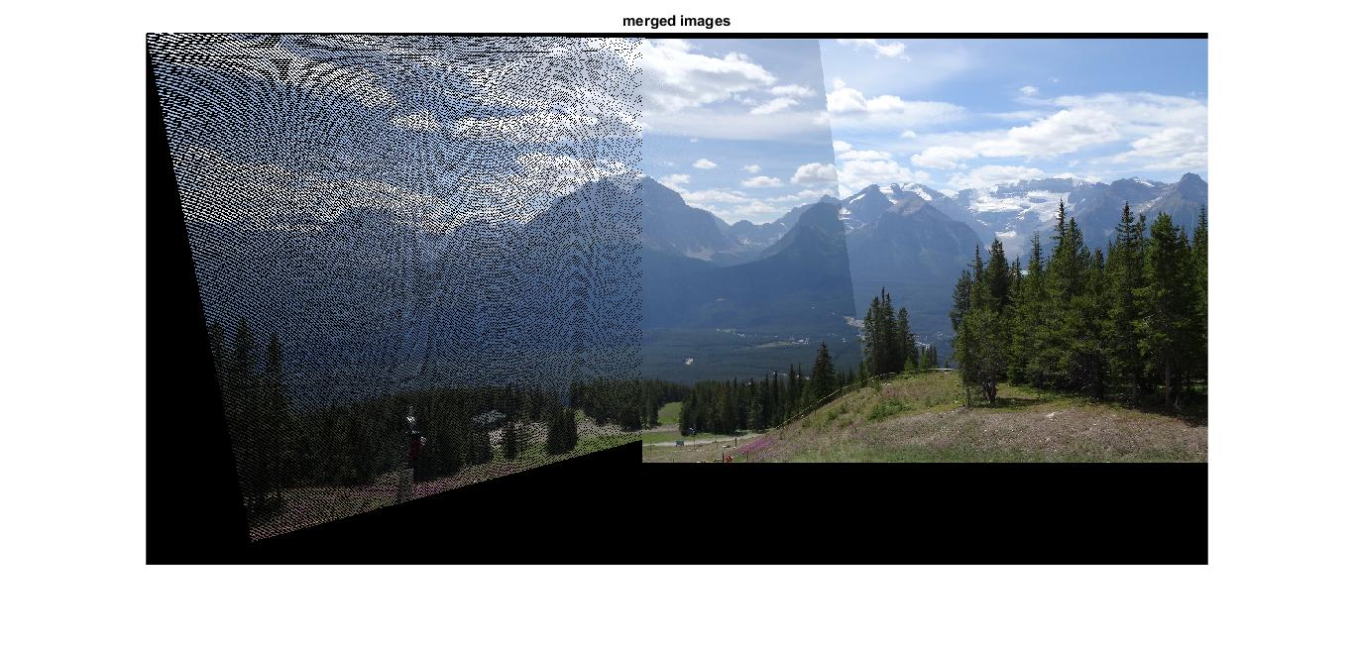
5. There is 2 main problems not dst pixels are reached by source hence the grid like appearance the second is the mapped pixels may be mapped to a fraction index and then we have to decide what how to map it.
6. 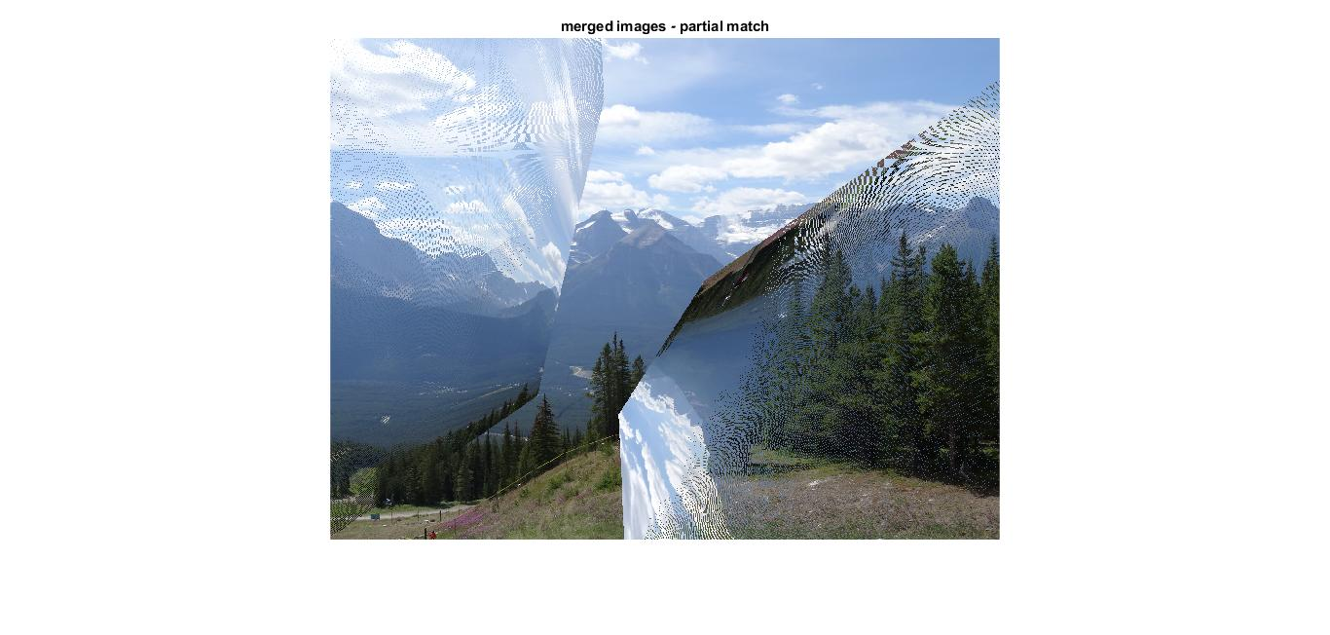The mapping is much worse because of wrongly matched point the mapping is in coherent and pint within the source image are not mapped with in the corner bounding box.

# Part 2 – dealing with outliers

1. .m file attached
2. .m file attached
3. The equation of the amount of iteration is given by: $K=\frac{\log\left(1-p\right)}{\log\left(1-w^{n}\right)}$ 
    so in our case $w=0.8 n=30$ $$thus for 90\%-K=\frac{\log\left(0.1\right)}{\log\left(1-{0.8}^{30}\right)}=1859 \\ for 99\%-K=\frac{\log\left(0.01\right)}{\log\left(1-{0.8}^{30}\right)}=3718$$ for 100% of course only an infinite amount of rounds can assure that.
4. 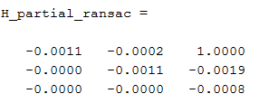 As can be seen in the result bellow using ransac the mapping quling is equivelint when using perfect matches in a naïve fashion or matches with ransac.  
   for the hyper parmeters we used max_err to be 5 pixels and inliners percent to be 80 this seem afficaint enough for this data set.

